# Mock Examination Dates and details

Subject content being examined (page number sin specification)

<https://filestore.aqa.org.uk/resources/computing/specifications/AQA-7516-7517-SP-2015.PDF>

1 Fundamentals of programming (page 11)

2 Fundamentals of data structures (page 16)

3 Systematic approach to problem solving (page 16)

4 Theory of computation (page 18)

5 Fundamentals of data representation (page 21)

6 Fundamentals of computer systems (page 29)

7 Fundamentals of computer organisation and architecture (page 32)

8 Consequences of uses of computing (page 37)

9 Fundamentals of communication and networking (page 38)

Paper 1 – Thursday 9th May2019 8:50 am start

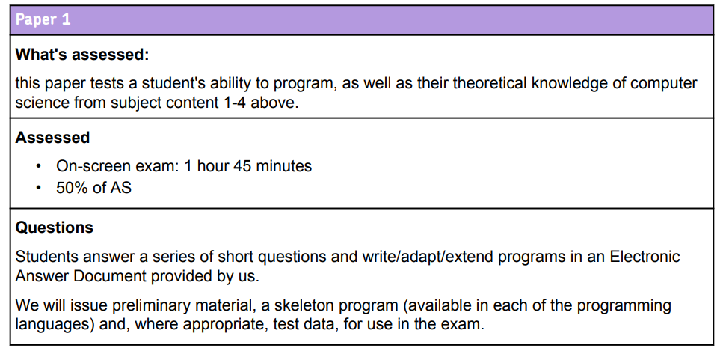

AS Grade Boundaries

|  |  |  |
| --- | --- | --- |
| % | Marks | Grade |
| 27% | 40 | E |
| 36% | 54 | D |
| 45% | 68 | C |
| 55% | 82 | B |
| 65% | 97 | A |
| 100% | 150 | A |

Paper 2 – Wednesday 22nd May 2019 08:30 am start

